Garrett Phillips

Dr. Long

Marketing 4480

Vungle A/B Testing Case Analysis

After analyzing the data provided regarding the algorithms, I would recommend Vungle to switch the algorithm to Kritzer and Guerin’s newer version. Although it falls short in a few metrics to the older algorithm, the newer program averages a higher eRPM than the existing. The case states that eRPM is the most valuable aspect of the program, and I agree as eRPM is based on the value of the advertisement. Because the new algorithm ultimately makes more effective revenue for Vungle, I would advise the company to switch to the newer version to maximize its profits. Although I would switch the algorithm, I would continue to run tests of the two to understand to drop in various aspects and how to increase them.

I began by taking the tracking of each algorithm, and converting them to their corresponding completion rate, click-through rate, conversion rate, and eRPM. These were all dependent variables with the type of algorithm being the independent variable. Because the newer algorithm had a significantly smaller sample size, I averaged each to account for this difference. After completing these statistics, I ran linear models in R studio to find which variables were different. The results are as follows.

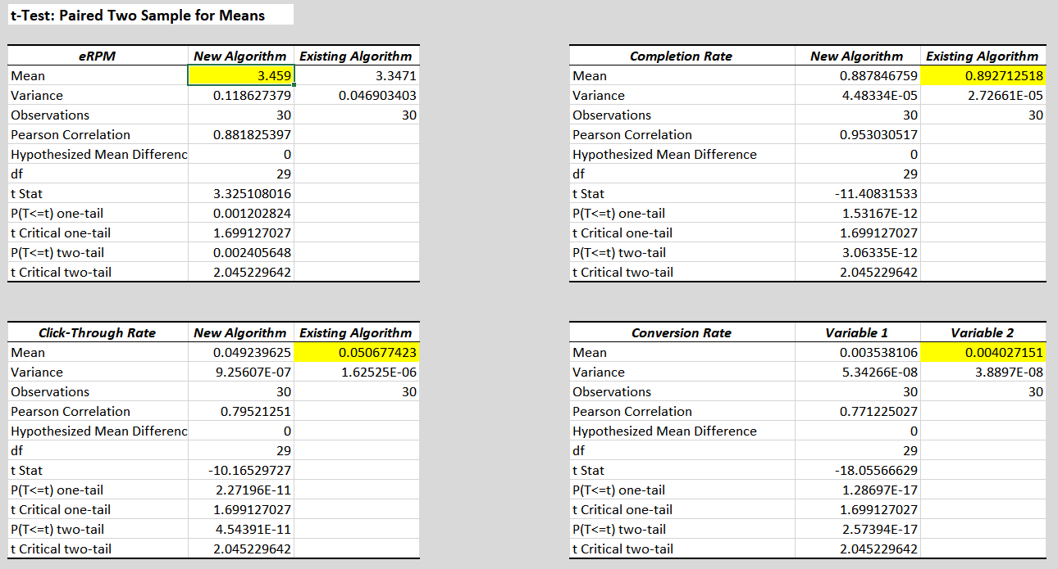

For all variables except eRPM, the old algorithm performed better. I am certain of this as my intercepts for all regressions were negative. All findings were found to be statistically significant as their p values were less than 0.05. This means that the algorithms did differ from each other on a performance basis in all results. One thing I noticed is the variance in the new algorithm’s eRPM is over twice that of the existing. I believe this could mean the new algorithm is effectively targeting some segments while lagging behind in others.

Vungle should adopt the new algorithm immediately to maximize its profits, but should look into exploring the segmentation aspect of the algorithm as well. I believe the new algorithm is making better use of the data than the existing one, and for this reason the data extracted is used more efficiently, and thus more valuable.

Excel Versus R

I preferred the model in Excel for this assignment for visual purposes. It was much easier for me to compare the two algorithms side by side. My results were the same in both programs, but with the formatting in Excel I never had to graze over a plethora of numbers looking for the important statistics. I do enjoy linear modeling in R much more than Excel in general, but for the purposes of this assignment I would choose Excel.